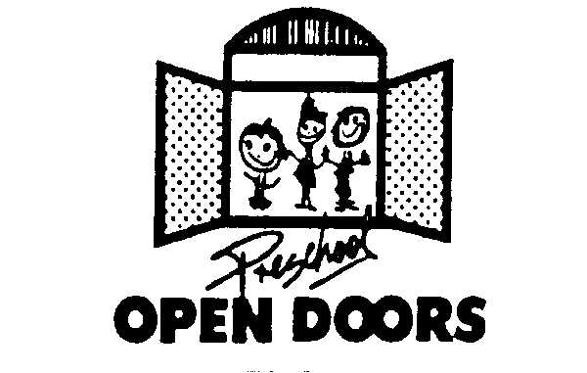
PRESCHOOL OPEN DOORS
SUMMARY SHEET FOR POD CHILD ASSESSMENT
1. Family & Preschool Information:
Child’s Name: |  | Child’s DOB: | / /
Last First Middle Month Day Year

Parent’s Name: |  | HANA case #:
Last First Middle

Name of Preschool: |  | Phone #:

Preschool director: |  | Email:

Date of Child’s Start at Preschool: | / / |  | POD School Year:

2. DHS 914B – POD Child Assessment – this Summary Sheet covers (check one only):
Pre-Assessment
Post-Assessment

Date of Assessment: | / / | Assessment Completed by:

3. Rating for each measure from DHS 914B POD Child Assessment (check only one rating per item):

Item 1: Relationships and Social Interactions with Peers
Not Yet Exploring Competencies Building Competencies
Exploring Competencies Integrating Competencies
Developing Competencies Applying Competencies

Item 2: Conflict Negotiation
Not Yet Exploring Competencies Building Competencies
Exploring Competencies Integrating Competencies
Developing Competencies Applying Competencies

Item 3: Self Control of Feelings and Behavior
Not Yet Exploring Competencies Building Competencies
Exploring Competencies Integrating Competencies
Developing Competencies Applying Competencies

Item 4: Reciprocal Communication and Conversation
Not Yet Exploring Competencies Building Competencies
Exploring Competencies Integrating Competencies
Developing Competencies Applying Competencies

Item 5: Understanding of Language (Receptive)
Not Yet Exploring Competencies Building Competencies
Exploring Competencies Integrating Competencies
Developing Competencies Applying Competencies

NOTE: DHS 914A POD “POD Child Assessment Summary Sheet” forms that are not received by the respective deadlines will affect the family’s POD payment, and DHS will issue a notice of adverse action to the family to terminate POD payments if the DHS 914A POD “POD Child Assessment Summary Sheet” is not received.

Deadlines: Pre-Assessment deadline: August 31 or within one (1) month from the child’s initial subsidy payment
Post-Assessment deadline: April 30

Original of the DHS 914A POD Child Assessment Summary – to DHS
1 copy of the DHS 914A POD Child Assessment Summary – 1 for preschool’s file

